Дата: 04.11.2022 Клас: 6-Б

Предмет: Англійська мова

Тема: Шкільні предмети.

Мета: формувати навички вживання нових лексичних одиниць з теми «Школа. Шкільні речі. Шкільні предмети» ; удосконалювати навички аудіювання й усного мовлення з опорою на лексико-граматичні структури; розвивати мовну здогадку; виховувати доброзичливе ставлення до співрозмовника.

Вчитель: Глуговська Л.Г.

Хід уроку

***1. Greeting***

Good afternoon, dear pupils! You are back at school having your lessons, meeting your friends and teachers.

***2. Warming up***

***Guess the riddles. Відгадайте загадки.***

1) What Creature walks on 4 legs in the morning 2 legs in the afternoon and three legs in the evening **Answer:** Man

2) I show all the world  
In just one swirl  
I show the desert  
I show the land.  
Where there are mountains  
And where there is sand.  
I show the oceans  
I show each sea  
Now answer the question:  
What can I be? **Answer:** **the globe**

***3. Grammar.***

***Modal verbs. The rule.*** p. 51.

**Modal verbs:** **can, could, may, must, should, might, have to**. We don’t use ‘to’ with modal verbs, except ‘have to’.

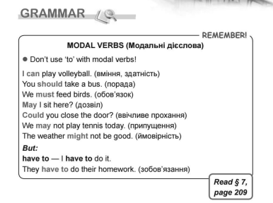

***Додатково перегляньте презентацію з поданої теми:***

[***https://naurok.com.ua/prezentaciya-modal-verbs-6-klas-250791.html***](https://naurok.com.ua/prezentaciya-modal-verbs-6-klas-250791.html)

***4. Grammar practice.***

Ex. 1 p. 52 Giving advice to the people using ‘should/shouldn’t’.

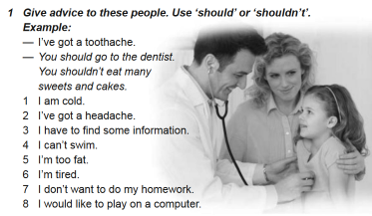

Sample answers:

1. You should put your warm sweater on. You should drink hot tea with lemon.

2. You should take a tablet of aspirin (Panadol, Nurofen). You should go to bed and have a rest.

3. You should use the Internet and surf it. You should use Encyclopedias.

4. You should join the swimming club.

5. You shouldn’t eat so much food. You should move more.

6. You should have a rest.

7. You should think about your knowledge and you grades at school.

8. You should do your homework first and then you may play on a computer.

***5. Reading***

Прочитайте правила поведінки у школі.

**THE RULES OF BEHAVIOUR AT SCHOOL**

1. We must be attentive at the lessons.

We mustn’t talk during the lessons.

2. We must walk quietly along the corridors.

We mustn’t run along the corridors.

3. We must arrive on time for the lessons.

We mustn’t be late for the lessons.

4. We must turn off our phones on the lessons.

We mustn’t use our phones on the lessons.

5. We must eat at the school canteen.

We mustn’t chew bubble gum on the lessons.

6. We must observe the purity of the school.

We mustn’t throw garbage everywhere in school.

7. We must show respect for all school staff.

We mustn’t be rude to someone at school.

8. We must carefully treat the property of school and take care of it.

We mustn’t damage the property of school.

9. We must wear only school uniform.

We mustn’t wear jeans at school.

10.We must do our homework regularly.

We mustn’t come to school without homework.

***6.Homework***

Домашнє завдання:

1. Опрацювати конспект уроку;

2. Вивчити правило про «Модальні дієслова».

**Надіслати виконані вправи у Вайбер (0964124047) – Людмила Григорівна або прикріпити на Human.**